Parents /Guardians:

Q & A Session

Time: 8:00-9:00

Where: Social Room



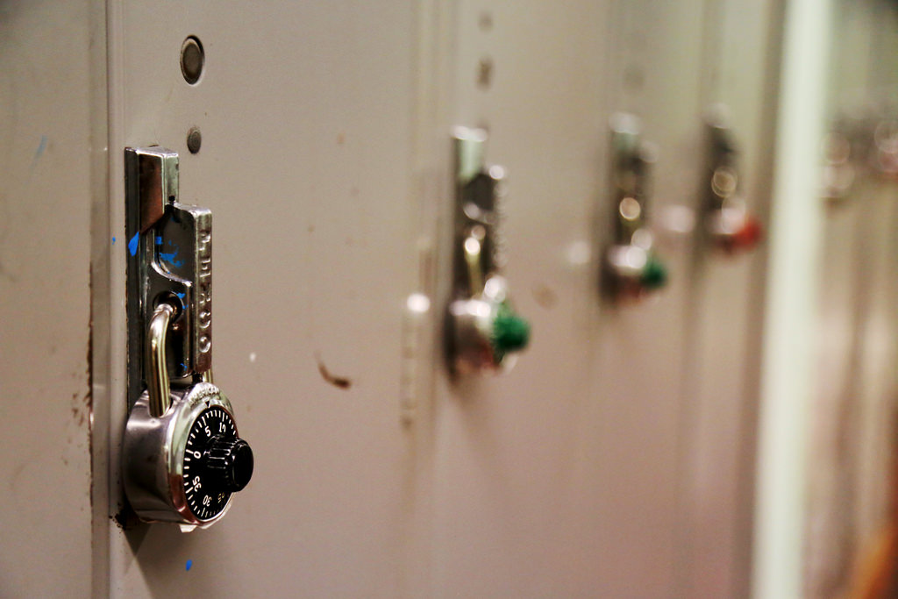

**Attention all 7th Graders**

**Bridge Program: Orientation**

**When:** August 13, 2018, **Time:** 9:00-2:30

**Where:** Lansing Eastern

**What:** Transitions-**“Sporting Tools for Success”**

**Why:** To prepare our

**Junior Quakers for Academics**

**& Social Readiness**

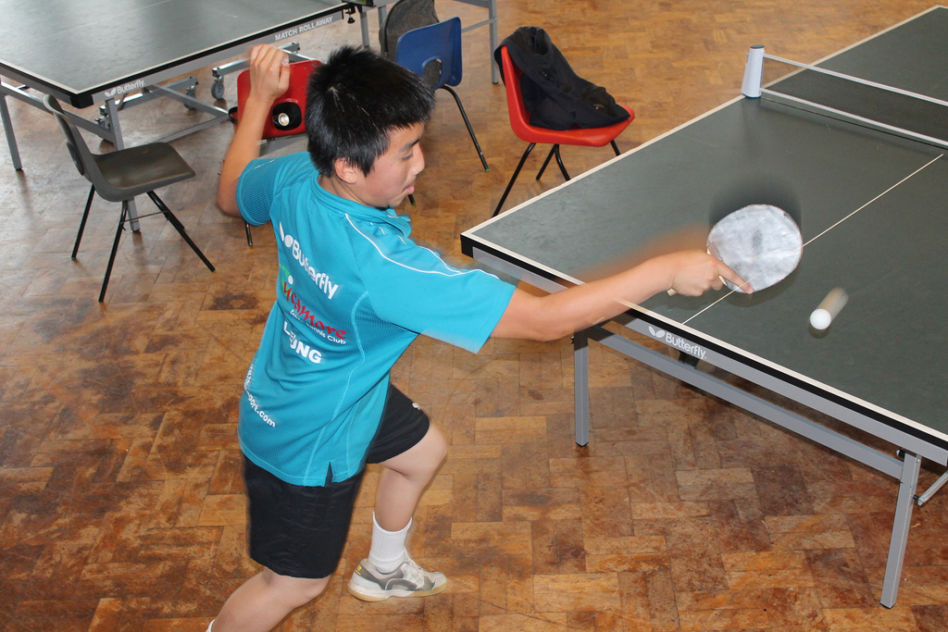



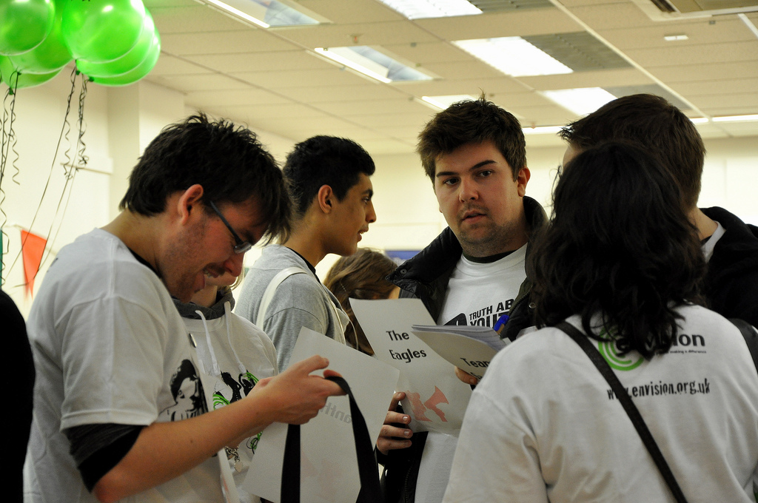

**Sporting with Reading & Math**



