Creating Classes for TI-Navigator

1. Request excel files of your class lists from Student Information

a. http://www.edline.net/pages/Lansing_SD/Teachers_Staff/Teachers___Staff
b. 3rd link on the left if at school/LSD (.Student Information for Teachers Only), 4th link if at home
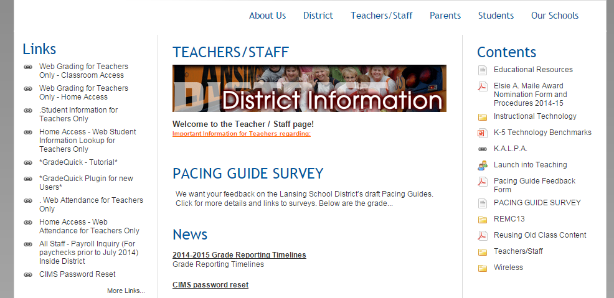

c. Log in using your CIMS information
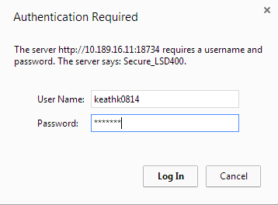

d. For each of your classes…
i. select Email Reports/Downloads
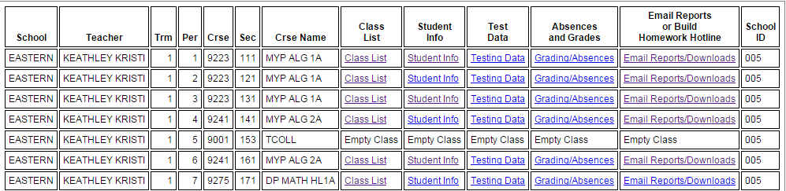

ii. And choose Email Excel File

2. Create a Class List in Excel
One class at a time…
a. Copy Columns A-E into a new Excel file

b. School Class Name School Name User Name StuNbr Password
c. Fill in user names : first 3 of LAST + first 3 of FIRST

d. Continue adding classes to the same file
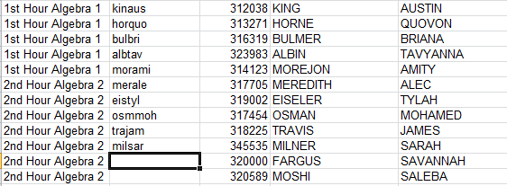

e. Save as a .csv file

3. Load class files to the Navigator Program
a. Click Add Classes in the Class Tab
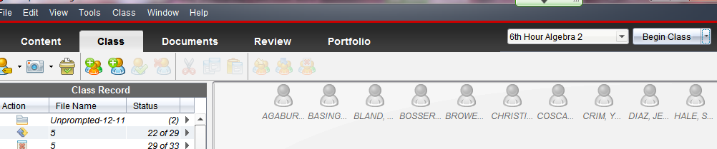
b. Load your .csv file
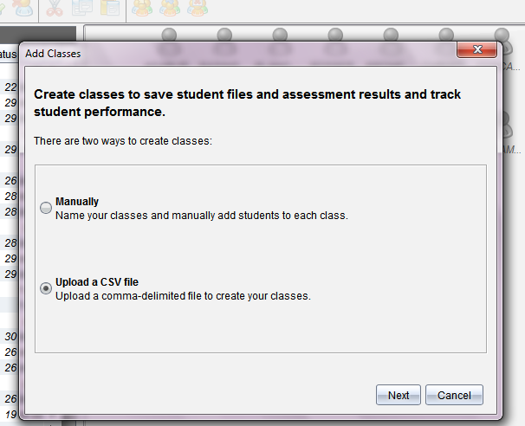

c. Select the Heading of each category from the drop down menus. They should match the “Navigator Fields” if you followed the directions above. Leave Student ID “Blank” or it may display student numbers!

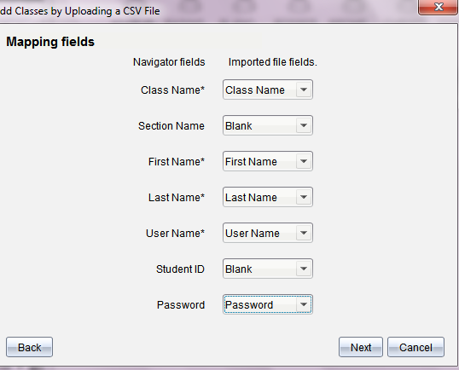

d. Select Next and your classes should all appear! Any duplicate IDs will need to be changed and will not be loaded. These students may be added individually, or changed in the .csv file and this 3rd process repeated.

