Synergy – Report Card Final Grades and Comments
Audience: Secondary Teachers, grades 6-12
This document describes how to enter final grades and comments in TeacherVUE.
To Set Final Grade Configurations:
- From the Grade Book Menu, Select Final Grade Config (please see below).
- From the dropdown box named Set all students to score type, choose the report card score type (i.e. Genesis Grading).
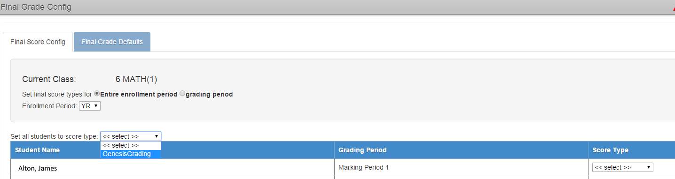
- Click the Save button to apply changes.

To Set Final Defaults for New Students:
- Choose the Final Grade Defaults tab.
- Select the Score type for the Grading periods (i.e. GenesisGrading).
- Select any other sections to apply the default settings.
- Choose Save Defaults or click Save & Apply To All Students, to apply these defaults to all current and new students.
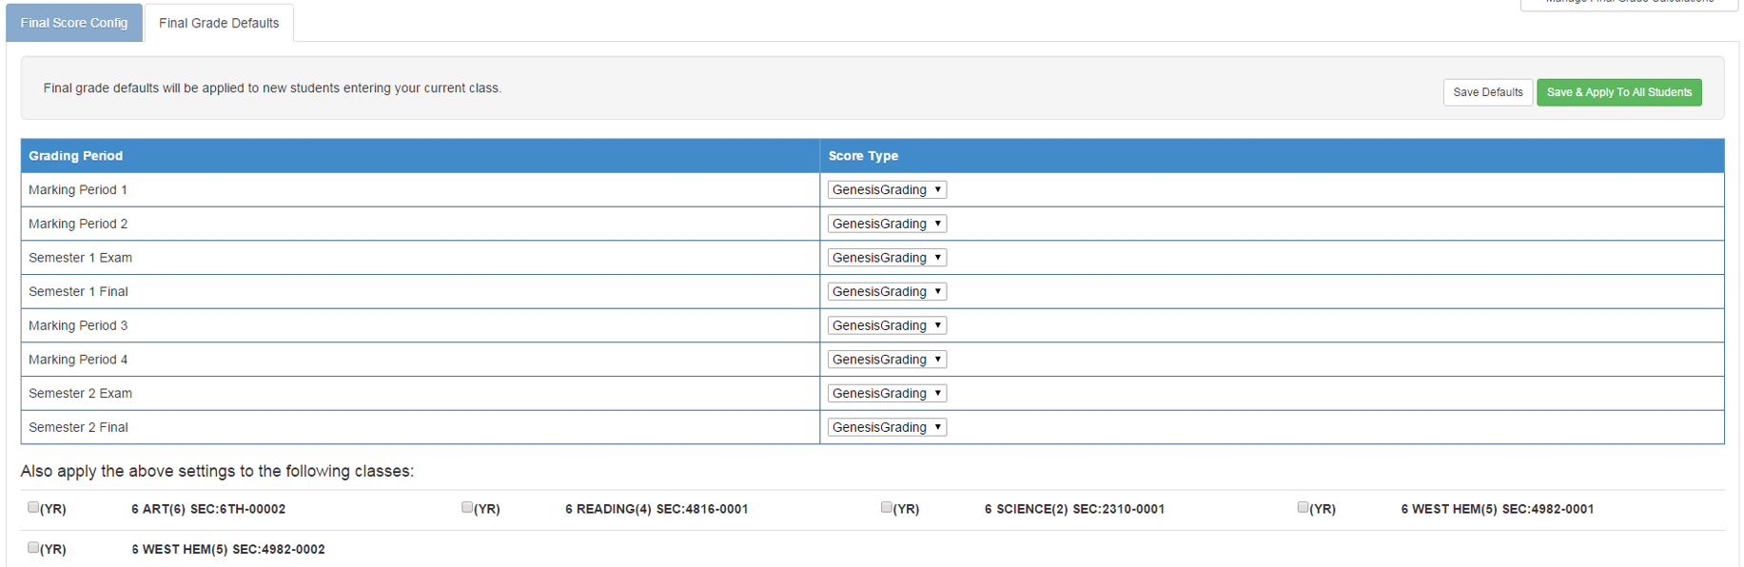

To Enter Report Card Final Grades and Comments
- Choose the Report Card menu from TeacherVUE. Select Students (see below).
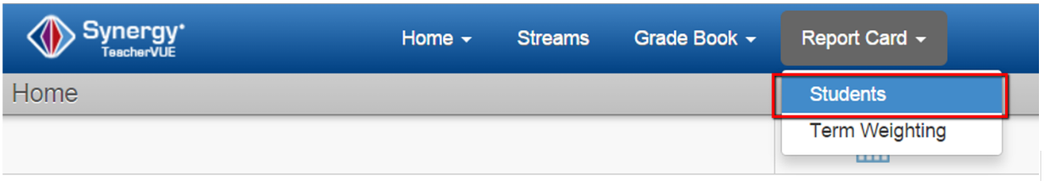
- Next, Click the Edit Final Grade and Comments link (see below).
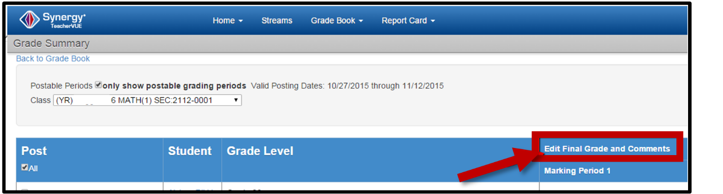
- Select Final Grade from drop down menu.
- Enter Comment 1, Comment 2, and Comment 3 Comments from the Drop Down menu. Comment Code descriptions are listed on the right side of the screen. If needed, click the green fill-down arrow to fill multiple columns with the same comment code.
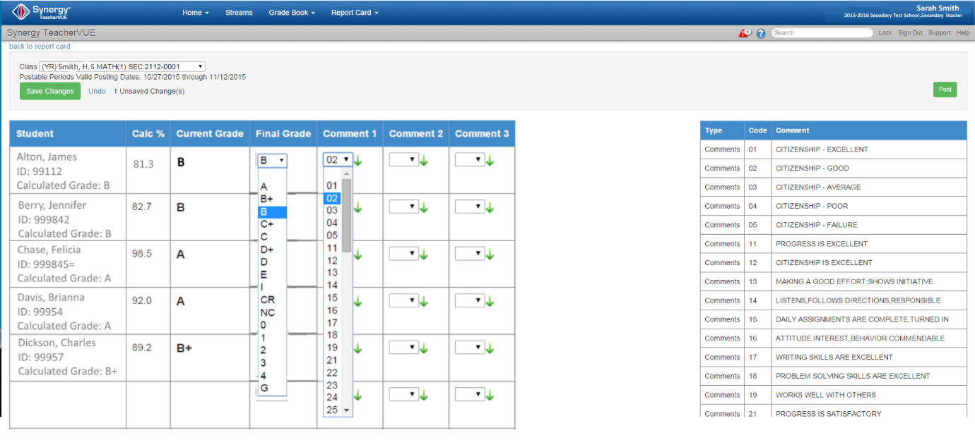
- Click the green button to record changes in the gradebook.
- Click the Post button to submit the final grades to the SIS. You should see a message indicating that you have successfully posted your grades.
.
How to Access the Gradebook Online Help Document:
- To access Gradebook Online Help, click the Help button from the Teacher Vue screen (see below).
- The Help Screen appears (below).
- Click Synergy Guides. Choose Grade Book.
- The user guide screen opens.
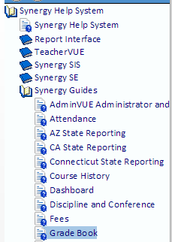

Sources: Synergy: Gradebook Secondary Manual

End of document.

