Synergy – How to Print Elementary Report Cards
Audience: Elementary Teachers, grades K-5
The following document describes how to view student report cards from TeacherVUE. It is intended for Elementary teachers in grades K through 5.
Steps:
- From the Report Card Menu in TeacherVUE, choose Students (as shown below).
Another screen will open which allows you to view report cards for the students.
- Click the View Report Cards button (located in the upper right of the window).
A new screen appears. Near the top of this screen you will see two buttons used to generate report cards. The two buttons are (1) Generate Class Report Cards and (2) Generate Blank Report Cards. Both buttons are discussed next.
Option # 1: Generate Class Report Cards
- Choose the Generate Class Report Cards button to generate report cards with the grades and comments entered that have been entered for each student. When clicked, a new screen will open displaying the report card results as a pdf.
Option #2: Generate Blank Report Cards
- Click the Generate Blank Report Cards button to generate a blank report card. Clicking this button will open a screen that displays a blank report card for each student as a pdf.
Other: How to Access the Gradebook Online Help Document:
- To access Gradebook Online Help, click the Help button from the TeacherVUE screen (see below).
- The Help Screen Appears (below).
- Click Synergy Guides. Choose Grade Book.
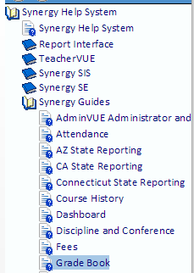

Sources:
Synergy Gradebook

End of document.

