Name ___________________________ School ____________________

Let’s Get Fooducated!

(adapted from Fooducate.com)

**Product: Ingredient List: Nutrition Facts:**



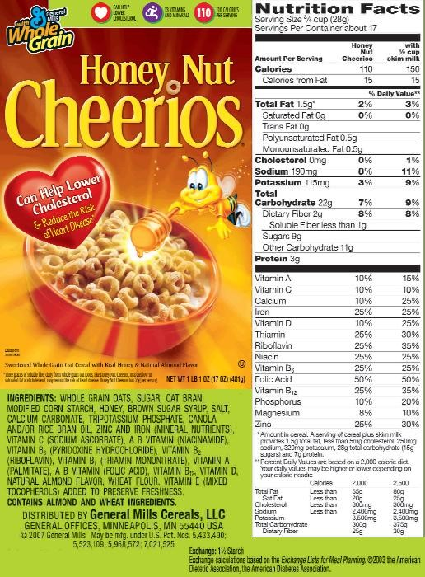

**1.** What do you think is used to sweeten this cereal?

______________________________________________________________

**2.** Underline all the sweeteners listed in the Ingredient List. How many did you find? ______________

**3.** How many grams of sugar per serving? ____________________________________________________

**4.** Approximately how many teaspoons of sugar are in a serving of this cereal? ___________________

(HINT: there are 4 grams of sugar per teaspoon)

**5.** Are there any nuts in Honey NUT Cheerios? _________________________________________________

**6.** What cereal do you like to eat? ____________________________________________________________

**7.** Fooducate recommends a cereal with 6 or less grams of sugar per serving.

Does this cereal have more sugar or less? _____________________________________________________

**Product: Ingredient List: Nutrition Facts:**

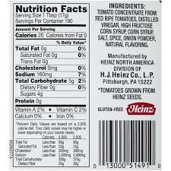

TOMATO CONCENTRATE

FROM RED RIPE TOMATOES,

DISTILLED VINEGAR, HIGH

FRUCTOSE CORN SYRUP,

CORN SYRUP, SALT, SPICE,

ONION POWDER, NATURAL

FLAVORING.

**1.** Read the ingredient list. What sweeteners are used here? ____________________________________

___________________________________________________________________________________________

**2.** What is a serving size for ketchup? Do you use more than that or less? _________________________

___________________________________________________________________________________________

**3.** How many grams of sugar are in a single serving of ketchup? _________________________________

**4.** How many teaspoons of sugar are in a single serving of ketchup? _____________________________

(HINT: there are 4 grams of sugar per teaspoon)

**5.** What other condiments could you use instead of ketchup? __________________________________