Name _________________________ School ____________________
Making My Own “MyPlate”

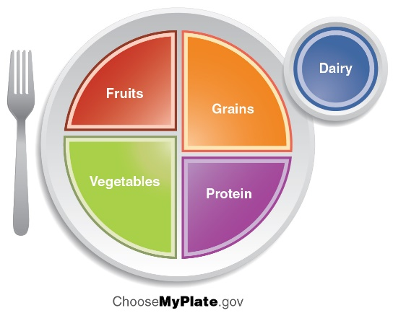
- Draw a big circle on this paper, with a smaller circle off to the side for the Dairy, and then draw lines dividing the plate like in the picture above.
- Next, write in foods in each section that you enjoy eating from that food group. You can draw the foods, write out the names of the food, or even cut and paste pictures into the plate if you want.

