Family implores mentally ill mother to tell them where she left her missing children
By Dan Morse November 10

Searching for answers in children’s disappearance
Family members of Catherine Hoggle have been trying to talk to her about what she might have done with her two missing children.
Oct. 23, 2014 Lindsey Hoggle poses for a portrait at her home near Gaithersburg, Md. Lindsey is the mother of Catherine Hoggle, a Montgomery County woman who is accused of abducting her two young children and putting them in danger. Matt McClain/The Washington Post
For more than a decade, Lindsey Hoggle has tried to sort through her daughter’s tangled mind. Never has it been so heartbreaking.
Their conversations these days last 20 minutes at the most. They are over the phone.
“I’m asking you as a mother,” Lindsey implored her daughter earlier this month. “Tell us where the children are.”
Catherine Hoggle, locked in a Maryland psychiatric hospital, sidestepped the question. She has done this for two months — with detectives, with a therapist, with her family. The 27-year-old Montgomery County woman is the last person known to have been with her youngest children: Jacob, 2, and Sarah, 3. Police fear that the toddlers are dead and are building a homicide case against Catherine.
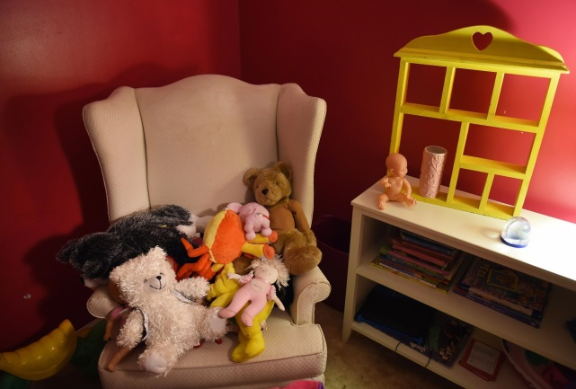
Items in Sarah Hoggle’s room are seen at her family’s apartment in Clarksburg, Md. (Matt McClain/The Washington Post)
Every day across the county, extended families of young parents with mental illness face the challenge of trying to help them and their children. They walk the narrow line of trying to show confidence while maintaining vigilant monitoring. They often fashion workable, if imperfect, solutions.
Catherine’s boyfriend and relatives had forged such a network — reordering their lives to try to always have another adult around the woman’s three children. She seemed to be getting better; her children appeared to be thriving.
Lindsey can’t bear to think of her grandchildren dead, can’t imagine that her daughter is a killer. It is hope that rests on the affection Catherine had shown for her children and the possibility that the young woman’s paranoid schizophrenia may have compelled her to do something inexplicable but not deadly — leaving the toddlers with people she’d just met, for example.
On the phone, there were no clear answers.
“I’m trying to do the right thing,” Catherine finally said.
Signs of trouble
The first signs of trouble came when Catherine, the oldest of four, was in middle school. She was bright, but increasingly struggled with her classwork.
She was diagnosed with a learning disability — problems with “executive functions” such as planning and organization. Then came doctors’ concerns about mood and bipolar disorder.
Complicating the search for answers was Catherine’s fear that she’d be stigmatized by mental illness. She could be vague and evasive, perhaps trying to avoid a specific label.
After high school, Catherine enrolled at a community college in Montgomery and, by 2007, had started waiting tables at the Greene Turtle, a Germantown sports bar, where she fell in love with a bouncer named Troy Turner. “It was a like a fairy tale,” she’d later say.
In the fall of 2008, Catherine gave birth to their first child, a son, and the family began a life in Harrisonburg, Va., with Troy starting a career selling timeshares. To give the young couple a break, Lindsey planned to watch the baby for two days. As Lindsey was leaving with her grandson, Catherine stuffed index cards into her mom’s back pocket: How to mix the formula, when to feed him, a reminder to keep pillows out of the crib.
That level of attentiveness aside, Troy began to notice something troubling: Catherine started to imagine that people were out to break up their family. He attributed it to postpartum depression, an explanation that seemed plausible as the behavior abated.
The couple had a girl, Sarah, in 2010, and a boy, Jacob, in 2012. They moved into a three-bedroom apartment in Montgomery, walking distance to a swimming pool, parks and playgrounds for the children.
The children formed a tight bond, the way siblings close in age can. When Sarah played with Jacob, she liked to imitate her mother by getting a small blanket. “Here. Mommy will cover you up,” she’d tell her brother. (Family members have asked that the oldest child, who is 6, not be identified to protect his privacy.)
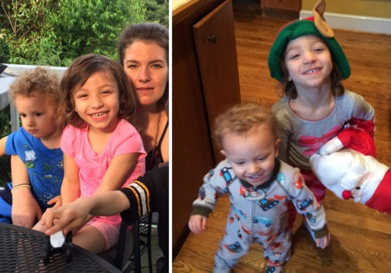
Left: Catherine Hoggle is seen in Montgomery County, Md., with her children, Jacob and Sarah Hoggle. Right: While Catherine Hoggle was in a psychiatric hospital north of Baltimore in January 2014, Sarah and Jacob Hoggle often played at their grandmother’s home in Darnestown. (Photos courtesy of Lindsey Hoggle)
But Catherine’s problems returned. To Troy, Lindsey and others, she seemed to seek control by withholding basic information.
“Which 7-Eleven did you go to?” Troy asked one day.
“The one in Germantown,” Catherine answered, knowing there were several in the area.
“Which one?”
“I already told you.”
Confusion seemed to lead to paranoia. In 2013, Catherine became convinced that Troy’s sister was regularly breaking into their apartment. Catherine filed court papers claiming his sister had stolen a $12.09 pack of toddler undershirts and a $30 plastic toy with a lion image.
“Matches our other yellow lion walker from the other kids,” Catherine wrote. “Except the missing one didn’t have a scratch on the eye from where the paint had worn from years of wear and tear and love.”
Catherine also asserted that the woman was following her.
“We go to the grocery store, she shows up there. We start going to a different grocery store, she starts showing up there,” Catherine told Montgomery County Judge Barry Hamilton. “I go to take my kids to the pediatrician, she shows up there. I go to my mom’s house, she shows up there.”
Hamilton declined Catherine’s request to issue a restraining order. As for the theft allegations, they were reviewed by the Montgomery State’s Attorney’s Citizen Complaint Bureau, which declined to pursue them.
<><><><>
Troy encouraged Catherine to go to therapy and take her medication. As things worsened, he couldn’t be sure she was doing either.
In the car one day, she began whispering, looking around as if the SUV was bugged. Troy pulled over so they could get out and talk on the side of the road. He told her no one could hear them, softening his message with humor.
“No one’s listening to us. We’re boring,” he said.
The former bouncer knew he could carry Catherine into a hospital. But what would she do once they arrived? Scream for the police? Start kicking and flailing?
Family members decided to seek a court-ordered psychiatric evaluation. On Aug. 13, 2013, sheriff’s deputies arrived at the apartment and took Catherine to a hospital.
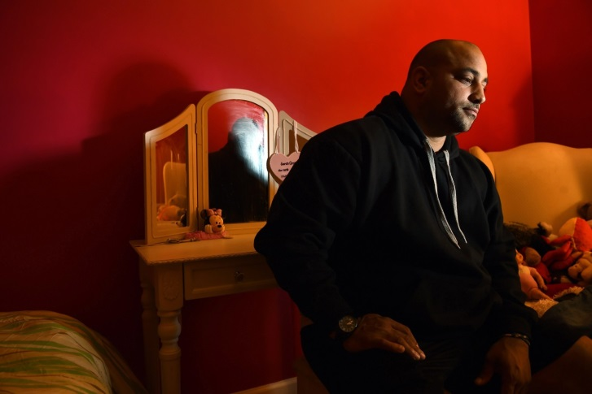
Troy Turner sits in the room of his daughter, Sarah Hoggle, at the family's apartment in Clarksburg, Md. (Matt McClain/The Washington Post)
Authorities were called to the apartment twice more. And by the end of the year, Catherine’s condition again worsened. She was involuntarily committed to the largest private psychiatric hospital in Maryland, Sheppard Pratt, just north of Baltimore.
“Do you remember when Daddy had to stay in the hospital for two days?” Troy told their children, recalling his hospitalization for asthma. “That’s what Mommy is doing. She just has to stay a little longer.”
Lindsey found herself following the story of Virginia state Sen. Creigh Deeds. He had been stabbed by his mentally ill son, who then fatally shot himself. Lindsey sent Deeds an e-mail to express her sympathy.
“While my daughter is closing in on three weeks of hospitalization,” Lindsey wrote, “she is still very fragile, and I only pray for the right direction.”
<><><><>
The goal of the U.S. mental health system is to get patients back into communities. By spring, Catherine was moving through transitional programs that allowed her to see her children.
Catherine took her medication and seemed to understand that she needed to keep her illness under control to be around the children.
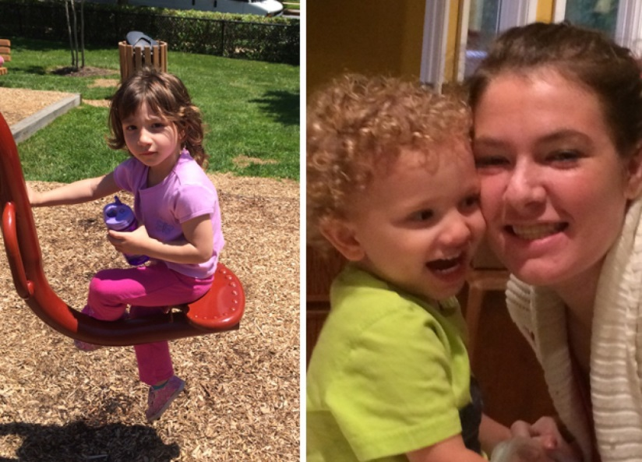
Left: Catherine Hoggle’s daughter, Sarah, 3, at a park in Montgomery County in March. Right: Catherine Hoggle plays with her youngest child, Jacob, 2, in Catherine’s mother’s kitchen in Darnestown, Md., on July 15. (Photos courtesy of Lindsey Hoggle)
Randy Hoggle, Catherine’s father, could see a return of the attentive parent he’d known. Catherine didn’t just read books to her children. She’d ask them why the story was funny or what it really meant.
But other times, Randy saw the fatigue and disconnection caused by Catherine’s medication. She would open the book and stare, leaving the children to turn the pages and figure out the story.
Troy observed Catherine’s overall progress and didn’t want to take the children away from their mother. Lindsey and Randy also wanted to keep the family together.
Troy didn’t think Catherine would intentionally hurt the children. Still, he knew her delusions could return without warning and he didn’t want her to be alone with their toddlers. Family members discussed a long-term strategy.
Troy set up a network — one that included Lindsey, Randy, Troy’s mother, his sister, Catherine’s siblings, Troy’s friends and a babysitter. They tried to always have a second adult near Catherine and the children.
The adults juggled their schedules to arrange care at two places: The Clarksburg apartment where Troy and Catherine lived and Lindsey’s home in Darnestown. Troy and Catherine discussed other options too: a day-care center, the hiring of an au pair.
<><><><>
The morning of Sept. 7, a Sunday, started off well. Troy and Catherine took Jacob and Sarah to their brother’s soccer game. Then everyone went to a park until it was time for Troy — who worked at night — to leave. He drove his family to Lindsey’s home. She was out, but Randy, who was divorced from Lindsey, had agreed to stay with Catherine and the children.
About 4 p.m., Catherine told her father she had a coupon for a pizza and asked to borrow his car to pick it up. Jacob was clinging to her.
“Let me just take him,” Catherine said.
For years, Randy had seen Catherine respond well to expressions of confidence. He thought this might be just such a chance. He let her leave with Jacob.
Two hours later, Catherine returned alone. She said she’d left Jacob at a friend’s house for a planned sleepover. The slightly smaller crowd — Randy, Catherine, Catherine’s oldest son and Sarah — returned to the Clarksburg apartment.
Troy arrived from work about midnight. He noticed that Jacob wasn’t in his toddler bed in the master bedroom. That wasn’t unusual. The little boy often got up and crawled into bed with a sibling. Troy went to sleep.
The next morning, Randy left early. Soon after, Troy was awakened by his oldest son, eager to get to school. He realized that Catherine and the younger children weren’t there.
A toy decorates Jacob Hoggle’s crib at his family's apartment in Clarksburg, Md. (Matt McClain/The Washington Post)
A wagon in the front yard of Lindsey Hoggle’s home in Darnestown, Md. (Matt McClain/The Washington Post)
Troy quickly got his son dressed, put him on the school bus and called 911. He told the operator that his two youngest children and their mother were missing, along with the family’s car. During the call, Catherine drove up.
Troy asked the 911 operator to wait.
“I got up early so you could sleep in,” she said. “I took Sarah and Jacob to a day care that is having a trial program.”
She told Troy the day care was in Germantown and that he might want to take a tour when they picked up the children. Troy was upset that she had taken the toddlers without telling him, but her story rang true.
Troy went back to the 911 operator. False alarm, he said.
Troy took Catherine to her treatment program, picked her up at 2 p.m. and said he wanted to retrieve Sarah and Jacob. Catherine told Troy she couldn’t remember the name of the day-care center, but could direct him there if they got close. The more they drove, the more evasive she became.
Hours passed, and Troy told her they had to go to a police station. On the way, Catherine asked to stop at a fast-food restaurant to get a drink. She slipped out the back and vanished.
Nothing to go on
During a massive search for the mother and her two children, only Catherine was found — four days after her disappearance. Police questioned her for hours, learning nothing about the children’s whereabouts. They brought Troy into the room.
“What are you doing here?” Catherine asked when he walked in.
She seemed relaxed. Nothing like the year before, when Catherine thought the car was bugged or someone was breaking into their apartment.
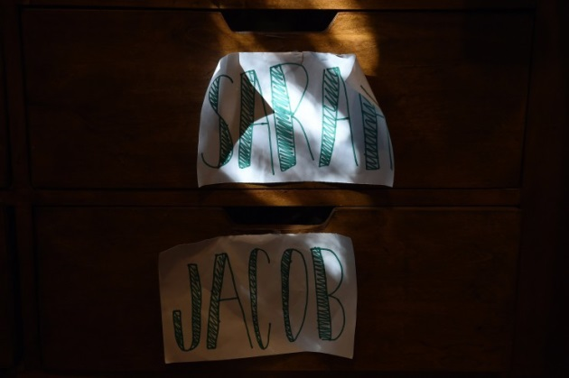
Drawers are marked for Sarah and Jacob at the home of their grandmother, Lindsey Hoggle. (Matt McClain/The Washington Post)
Sarah Hoggle’s room at her family’s apartment in Clarksburg, Md. (Matt McClain/The Washington Post)
“I’m here, hopefully, to find out where my kids are, and I’m here to see you, too,” Troy remembers saying.
Like the detectives before him, Troy returned again and again to the same question: Where are the children? Catherine spoke cryptically about leaving them with a woman named Erin. But she would not go any further.
These days, Catherine is being held at the maximum-security Clifton T. Perkins psychiatric hospital, where doctors are evaluating whether she is well enough to participate in court proceedings. She is charged with abduction, neglect and hindering a police investigation. She calls family members, who ask her to open up about Sarah and Jacob.
“They’re fine, Dad,” Catherine recently told Randy. “I promise you they’re alive.”
He asked her to be specific.
“I can’t talk about that where I am,” she said.
In conversations with Troy and Lindsey, Catherine offered some hope, saying she wanted to guide police to the children.
On Thursday — knowing that Montgomery prosecutors were about to act on Catherine’s offer — Troy and Lindsey took their seats in a courtroom. Catherine was brought in, a blank expression on her face. Lindsey tried to make eye contact, but Catherine only looked down.
State’s Attorney John McCarthy asked the judge to let Catherine leave for a few hours with the police. But her attorney, David Felsen, said Catherine had just told him that she didn’t want to talk to the police or go with them.
Judge Eugene Wolfe denied the request.
As the hearing ended, Lindsey walked toward Catherine. She wanted to tell her something: You are my daughter, and I love you.
A bailiff stepped between them. But it didn’t matter. Catherine had turned away and was walking out.
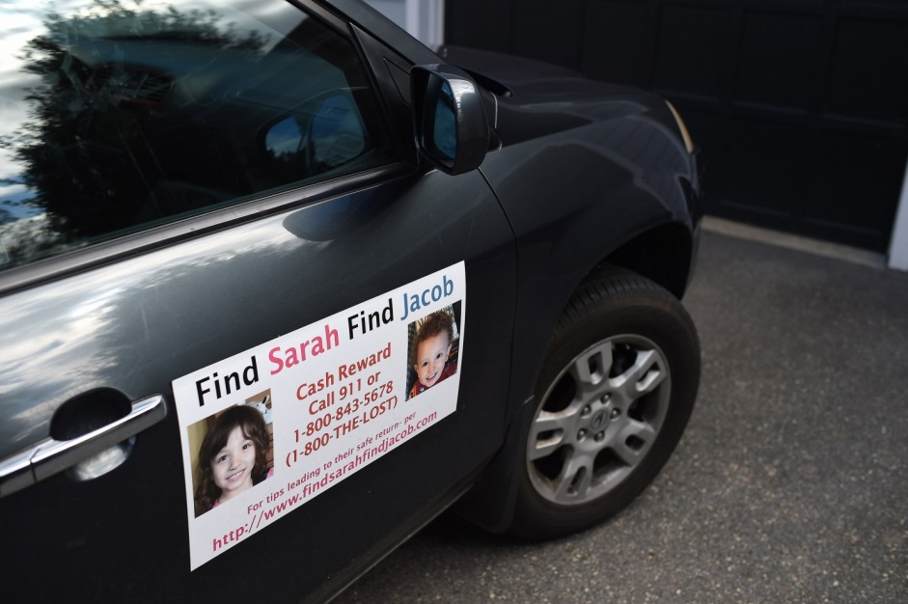
Grandmother Lindsey Hoggle has a sign on her vehicle that includes photos of Sarah and Jacob and a URL to a Web site (www.findsarahfindjacob.com). (Matt McClain/The Washington Post)

