
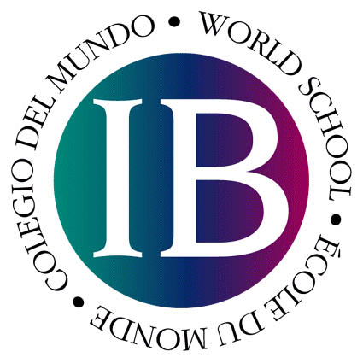
The IB Learner Profile

Students who participate in IB Programs develop to become:

Inquirers
Their natural curiosity is nurtured. They acquire the skills necessary to conduct constructive inquiry and research, and become independent active learners. They actively enjoy learning and this love of learning will be sustained throughout their lives.

Knowledgeable
They explore concepts, ideas and issues which have global relevance and importance. In so doing, they acquire, and are able to make use of, a significant body of knowledge across a range of disciplines.

Critical Thinkers
They exercise initiative in applying thinking skills critically and creatively to approach complex problems and make reasoned decisions.

Communicators
They understand and express ideas and information confidently and creatively in more than one language and in a variety of modes of communication.

Risk-Takers
They approach unfamiliar situations with confidence and forethought, and have the independence of spirit to explore new roles, ideas and strategies. They are courageous and articulate in defending those things in which they believe.

Principled
They have sound grasp of the principles of moral reasoning. They have integrity, honesty, a sense of fairness and justice and respect for the dignity of the individual.

Caring
They show empathy, compassion and respect towards the needs and feelings of others. They have a personal commitment to action and service to make a positive difference to the environment and to the lives of others.

Open-Minded
Through an understanding and appreciation of their own culture, they are open to perspectives, values and traditions of other individuals and cultures and are accustomed to seeking and considering a range of viewpoints.

Balanced
They understand the importance of physical and mental balance and personal well-being for themselves and others. They demonstrate perseverance and self-discipline.

Reflective
They give thoughtful consideration to their own learning and personal development. They are able to analyze their strengths and weaknesses in a constructive manner.

