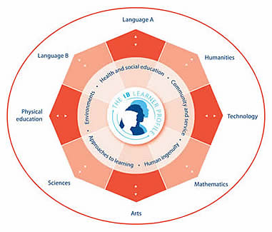
What Does the IB Middle Years Curriculum Contain?
The curriculum contains eight subject groups together with a core made up of five areas of interaction.
This is illustrated by means of an octagon with the five areas of interaction at its centre.
Students study subjects from each of the eight subject groups through the five areas of interaction: approaches to learning, community and service, human ingenuity, environment, and health and social education.
The five areas of interaction are:
- Approaches to learning (ATL): Through ATL teachers provide students with the tools to enable them to take responsibility for their own learning, thereby developing an awareness of how they learn best, of thought processes and of learning strategies.
- Community and service: This component requires students to take an active part in the communities in which they live, thereby encouraging responsible citizenship.
- Human ingenuity: Students explore in multiple ways the processes and products of human creativity, thus learning to appreciate and develop in themselves the human capacity to influence, transform, enjoy and improve the quality of life.
- Environments: This area aims to develop students’ awareness of their interdependence with the environment so that they understand and accept their responsibilities.
- Health and social education: This area deals with physical, social and emotional health and intelligence—key aspects of development leading to complete and healthy lives.

What is so Special about IB Programmes?
- IB programmes are recognized around the world and ensure an increased adaptability and mobility for IB students.

- The curriculum and pedagogy of IB programmes focus on international perspectives of learning and teaching, while insisting that students fully explore their home culture and language.

- IB World Schools must undergo an exhaustive authorization process in order to offer one or more of the programmes, which includes a study of the school’s resources and commitment to the IB mission and philosophy.

- IB teachers participate in a wide variety of professional development opportunities to constantly update their knowledge and share their expertise with colleagues around the world.

- Many students graduating from the Diploma Programme find that it enhances their opportunities at tertiary institutions. The IB works closely with universities around the world to gain recognition for IB programmes.

- The core components of IB programmes encourage students to participate in creative and service-oriented activities, while at the same time emphasizing the importance of reflection on a personal and academic level.

- The IB produces publications for schools to inform and support them as they offer IB courses. It is now beginning to produce material for use directly with students and to work closely with selected publishers and providers to offer material for students. These materials only will carry an IB logo.

Please visit the website www.ibo.org for more information about International Baccalaureate programs.

