Monday Memo, June 1, 2015 Finals Week! Please have final exams into main office by 4:00 p.m. today!
I must say that it was a wonderful feeling to write June 1st on this memo! It seems like the school year flew by, and yet it seems we all need a well- deserved break. Congratulations to all for a successful school year. We accomplished and survived many changes. And as we all know change is difficult for most humans. Summer will be a great time to relax and reflect. Please enjoy time with family and friends this summer.

Commencement was held Saturday. The program was awesome and the students looked so good in their caps and gowns. Deja Cooper sang the national anthem beautifully. It brought tears to my eyes. We also had a foursome (Deja Cooper, Maribel Ovalle, Gabriel Manuel, and Sabrina Ismail) who sang, Stand up for Love, by Destiney’s Child. It brought the seniors to their feet. Thanks to the staff who attended and helped make commencement a success. Thanks to Sue Mills, Lee Howell, Susan Christian, and Robin Coe for their help. Also, commencement would not happen without our wonderful band, and director Mauricio DeRosso. Thank you all!

The IB Exhibition, IB Induction and Open House was held on Wednesday. Many students and parents attended the event; hosted by Emily Oberlitner and Ann Jones. Our current IB graduates and IB alumni spoke eloquently about the IB program and their experiences. Post Oak students showcased their exhibitions in the foyer, and performed a Chinese dance. The event is always a wonderful way to showcase our IB program. Thanks to all our staff who attended the evening.

Senior Awards was held on Thursday morning. We have not held Senior Awards in the a.m. in a very long time. It went very well, and was finished in 1 ½ hours, a record time. Thanks to Mrs. Coe for her exemplary organizational skills. This event is a huge undertaking. We handed out over 500,000 in scholarship money. We will reflect and get feedback as to the morning time, as we begin planning for next year.

Thursday, evening Emily Oberlitner and I attended a school open house as Lansing Charter Academy. We were one of 6 schools with a table to showcase our school. The event was not well attended, but we did talk to a few 8th grade students and parents.

The spring carnival was resurrected from 8 years ago, thanks to our student council. We had wonderful weather and everyone had a good time.
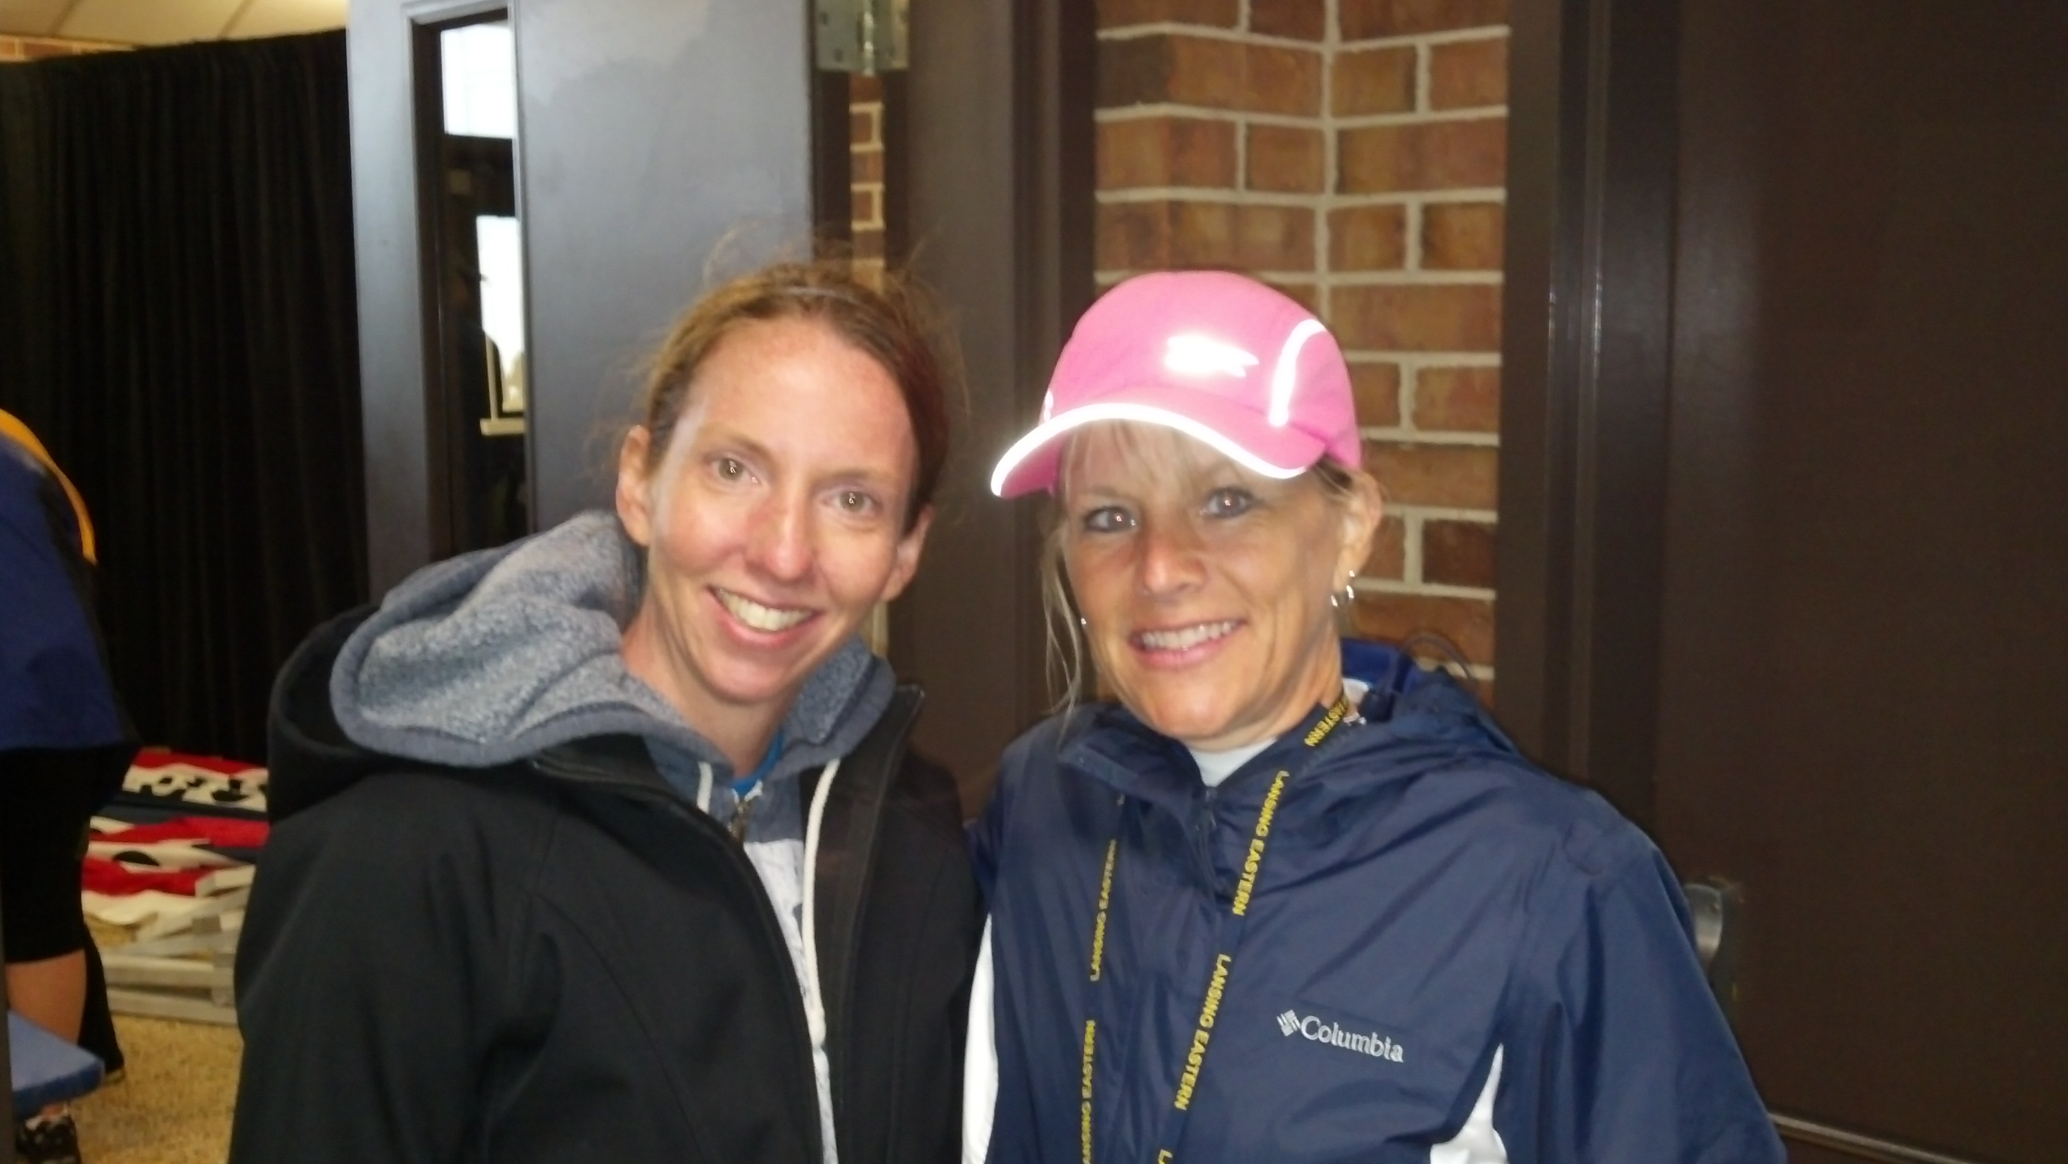
At the same time we had a pizza party and graduation practice for the seniors. I don’t think we could pack anymore into one day. Thanks to Mindy Salais and Leanne Weber for supporting our students as they planned the carnival.

And to top off the day, on Friday night our students presented their annual spring band concert. The concert was fantastic. The auditorium was packed with parents and friends. Thanks to Ms. Hicks and her intern, Mr. William Blythe for the performance.

Last but not least, we held our first annual 5K Quaker Dash on Sunday, May 31st! The rain stopped at exactly 10 a.m. as I predicted ☺ We had many runners including staff and alumni participate in the run. Mr. Christian and Mr. Blakslee were the front runners, and I brought up the rear. Many thanks to Michelle Jen, Kitty Lynch, and our PTSA. We could have accomplished this fundraiser without them! The plan is to raise funds each year for teacher grants, and to Michelle Jen and Kitty Lynch
support Eastern technology needs.
I don’t think we could have packed another event into last week, but it was so worth it. We are “fighting for the fun” at Eastern High School.
Locker Clean out:
7/8 grade students: Monday June 1st: Even number classrooms -3:00-3:15 , Odd number classrooms- 3:20-3:35
Students will return locks to their 7th hour teacher, and staff will return bag of locks to Ms. Chavez. Teachers will receive a bag and locker cards for students to write the combination
9-11 grade students: Tuesday, June 2- 8:20-8:35 a.m.
Students will return their lock to their 1st hour 1st semester teacher, and staff will return bag of locks to Ms Dillard in main office.
Teachers will receive a bag and locker cards for students to write their combination.

Have an awesome final week! Donna
Important Dates
June 1 Locker Clean out- 7/8 grade
June 1 New full Diploma Programme workshop for all new full DP candidates, 4:00-6:00 p.m.
June 2 Locker Clean out- 9-11 grade
June 1 PTSA meeting, 6:30 p.m. Social Room
June 5 Last day of school; STAFF BBQ IN COURTYARD, 11:30-12:30, Hugh Spag Award Announced

End of the Year SIG Wrap-Up
Thank you to all of the members of the SIG team. It is never easy taking a risk and starting a new position. Thank you to all teachers and staff for your willingness to work with the SIG team in their new roles!

PBIS

Rick Couturier, our SIG coach will be working with our administrators this summer to have a PBIS system in place. Stay tuned in to your district email for training opportunities this August. We will need “All Hands on Deck” in the fall. Everyone should expect to be a part of the system of providing positive behavior supports and interventions for our students.

Technology Training
There are still openings in all three dates for technology training. If you sign up after June 5, or if your plans change over the summer, please email Jaime Gundrum at jaime.gundrum@lansingschools.net or call 517-755-4417.

Instructional Mentors and Data
The IM’s are working on a plan to provide supports for teachers in the fall both in teams and individually. Supports will include leading discussions around data, observing and providing feedback, co-planning, and facilitating peer-to-peer observations. More details will be available in the fall.

Staff End of Year Celebration – Golf Outing
Golfer or not, come out to celebrate the end of the school year at the 2nd annual Quaker golf outing. The outing will be Thursday, June 4th at the Grand Ledge Country club. Plan on arriving at 1:30 for our 2pm tee time. $25 for 9 holes and cart, and $15 if you just want to ride around in the cart. Watch for a sign up in your mailbox soon. Proceeds from this event will help support the annual IB Historical Trip. See Mindy Salais or Leanne Weber if you have questions.

No Delayed Start This Week

ILC 4 – Week 17 (6/1-6/5)
Enter ILC 4 Assessment Scores into the Google Sheet by the end of the day 6/1. Turn in paper copy of the score log into the box in the main office.

