Class/grade: Age group:
School: School code:
Title:
Teacher(s):
Date:
Proposed duration:
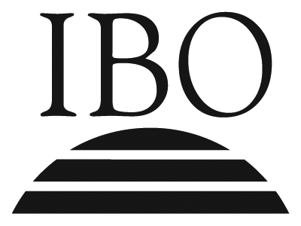
PYP planner
1. What is our purpose?
To inquire into the following:
- transdisciplinary theme

- central idea

Summative assessment task(s):
What are the possible ways of assessing students’ understanding of the central idea? What evidence, including student-initiated actions, will we look for?

Planning the inquiry

2. What do we want to learn?
What are the key concepts (form, function, causation, change, connection, perspective, responsibility, reflection) to be emphasized within this inquiry?

What lines of inquiry will define the scope of the inquiry into the central idea?

What teacher questions/provocations will drive these inquiries?

© International Baccalaureate Organization 2007
Planning the inquiry
3. How might we know what we have learned?
This column should be used in conjunction with “How best might we learn?”
What are the possible ways of assessing students’ prior knowledge and skills? What evidence will we look for?

What are the possible ways of assessing student learning in the context of the lines of inquiry? What evidence will we look for?

4. How best might we learn?
What are the learning experiences suggested by the teacher and/or students to encourage the students to engage with the inquiries and address the driving questions?

What opportunities will occur for transdisciplinary skills development and for the development of the attributes of the learner profile?

5. What resources need to be gathered?
What people, places, audio-visual materials, related literature, music, art, computer software, etc, will be available?

How will the classroom environment, local environment, and/or the community be used to facilitate the inquiry?

© International Baccalaureate Organization 2007
Reflecting on the inquiry
6. To what extent did we achieve our purpose?
Assess the outcome of the inquiry by providing evidence of students’ understanding of the central idea. The reflections of all teachers involved in the planning and teaching of the inquiry should be included.

How you could improve on the assessment task(s) so that you would have a more accurate picture of each student’s understanding of the central idea.

What was the evidence that connections were made between the central idea and the transdisciplinary theme?

7. To what extent did we include the elements of the PYP?
What were the learning experiences that enabled students to:
- develop an understanding of the concepts identified in “What do we want to learn?”

- demonstrate the learning and application of particular transdisciplinary skills?

- develop particular attributes of the learner profile and/or attitudes?

In each case, explain your selection.

© International Baccalaureate Organization 2007
Reflecting on the inquiry
8. What student-initiated inquiries arose from the learning?
Record a range of student-initiated inquiries and student questions and highlight any that were incorporated into the teaching and learning.

At this point teachers should go back to box 2 “What do we want to learn?” and highlight the teacher questions/provocations that were most effective in driving the inquiries.

What student-initiated actions arose from the learning?
Record student-initiated actions taken by individuals or groups showing their ability to reflect, to choose and to act.

9. Teacher notes

© International Baccalaureate Organization 2007

